DESIGNING A CHAT BOT APPLICATION

Aim :
To design and develop an HR Employee Support Chatbot using HTML, CSS, and JavaScript that provides instant responses to employee queries related to leave policies, salary details, company policies, and basic greetings.

Description:
The HR Employee Support Chatbot is a web-based chatbot interface created to assist employees with common HR-related questions. It helps reduce repeated manual work for the HR department by automatically replying to frequently asked questions.
The chatbot is designed with an attractive and professional user interface using HTML for structure, CSS for styling, and JavaScript for chatbot logic.
It can respond to:
- Basic greetings like Hi, Hello
- Closing messages like Bye
- Appreciation messages like Thank you
- HR queries related to:
  - Leave policies
  - Salary information
  - Company rules and policies
This chatbot improves communication speed, saves HR time, and provides employees with quick access to essential information.

CHAT JAVASCRIPT:
const data = {
leave: {
keys: ['leave', 'vacation', 'sick'],
rows: [['Annual', '21 days'], ['Sick', '10 days'], ['Casual', '7 days']]
},
salary: {
keys: ['salary', 'pay', 'payslip'],
rows: [['Pay Date', '28th'], ['Increment', '8%-20%'], ['Appraisal', 'April']]
},
policy: {
keys: ['policy', 'wfh', 'dress'],
rows: [['Work Time', '9 AM - 6 PM'], ['WFH', '2 days/week'], ['Notice', '60 days']]
},
benefits: {
keys: ['benefit', 'insurance', 'medical'],
rows: [['Insurance', '₹5L'], ['Meal Card', '₹2500'], ['Gym', '₹1000']]
}
};

function time() {
return new Date().toLocaleTimeString([], { hour: '2-digit', minute: '2-digit' });
}

function card(rows) {
return `<div class="info-card">
${rows.map(r => `<div class="row"><span>${r[0]}</span><span>${r[1]}</span></div>`).join('')}
</div>`;
}

function addMsg(msg, who) {
const box = document.getElementById("messages");
box.innerHTML += `
<div class="msg ${who}">
${who === 'bot' ? '<div class="bot-icon">🤖</div>' : ''}
<div>
<div class="bubble">${msg}</div>
<div class="timestamp">${time()}</div>
</div>
</div>`;
box.scrollTop = box.scrollHeight;
}

function reply(text) {
text = text.toLowerCase();

for (let item of Object.values(data)) {
if (item.keys.some(k => text.includes(k))) {
return card(item.rows);
}
}

if (text.includes("hi") || text.includes("hello")) return "Hello 👋 Welcome to HR Support!";
if (text.includes("bye")) return "Goodbye 👋 Have a great day!";
if (text.includes("thank")) return "You're welcome 😊";

return "Please contact HR Portal for more details.";
}

function sendMsg() {
const input = document.getElementById("userInput");
const msg = input.value.trim();
if (!msg) return;

addMsg(msg, "user");
input.value = "";

setTimeout(() => addMsg(reply(msg), "bot"), 500);
}

CHAT CSS:
body{
font-family: 'DM Sans', sans-serif;
background:#0f0f13;
color:#fff;
display:flex;
justify-content:center;
align-items:center;
height:100vh;
}

.shell{
width:420px;
height:720px;
background:#18181f;
border-radius:20px;
display:flex;
flex-direction:column;
overflow:hidden;
}

.messages{
flex:1;
padding:15px;
overflow-y:auto;
}

.bubble{
padding:10px 14px;
border-radius:15px;
margin:5px 0;
}

.user .bubble{background:#6c63ff;color:white;}
.bot .bubble{background:#222230;}

.input-area{
display:flex;
padding:10px;
}

input{
flex:1;
padding:12px;
border-radius:20px;
border:none;
outline:none;
}

button{
margin-left:10px;
padding:12px 18px;
border:none;
border-radius:50%;
background:#6c63ff;
color:white;}

CHAT HTML:
<!DOCTYPE html>
<html lang="en">
<head>
<meta charset="UTF-8" />
<meta name="viewport" content="width=device-width, initial-scale=1.0"/>
<title>HR Assistant — PeopleDesk</title>
<link href="https://fonts.googleapis.com/css2?family=DM+Serif+Display:ital@0;1&family=DM+Sans:wght@300;400;500;600&display=swap" rel="stylesheet"/>
<link rel="stylesheet" href="chat.css">
</head>
<body>
<div class="orb2"></div>

<div class="shell">

<!-- Header -->
<div class="header">
<div class="avatar">

<div class="online-dot"></div>
</div>
<div class="header-info">
<h1>PeopleDesk AI</h1>
<p>HR Virtual Assistant · Always available</p>
</div>
<div class="header-badge">HR Bot</div>
</div>

<!-- Quick topic chips -->
<div class="chips">
<div class="chip" onclick="quickSend('Leave Policy')"> Leave Policy</div>
<div class="chip" onclick="quickSend('Salary Details')"> Salary</div>
<div class="chip" onclick="quickSend('Company Policies')"> Policies</div>
<div class="chip" onclick="quickSend('Benefits')"> Benefits</div>
</div>

<!-- Messages -->
<div class="messages" id="messages">

<div class="date-divider">Today</div>

<div class="msg bot">
<div class="bot-icon"></div>
<div>
<div class="bubble">
Hello! I'm <strong>PeopleDesk AI</strong>, your HR assistant.<br/><br/>
I can help you with leave policies, salary queries, company guidelines, and more. How can I assist you today?
</div>
<div class="timestamp">9:00 AM</div>
</div>
</div>

</div>

<!-- Input -->
<div class="input-area">
<div class="input-wrap">
<button class="attach-btn" title="Attach file">📎</button>
<input type="text" id="userInput" placeholder="Ask about leave, salary, policies…" onkeydown="if(event.key==='Enter') sendMsg()" />
</div>
<button class="send-btn" onclick="sendMsg()" title="Send">
<svg viewBox="0 0 24 24" xmlns="http://www.w3.org/2000/svg">
<path d="M2.01 21L23 12 2.01 3 2 10l15 2-15 2z"/>
</svg>
</button>
</div>

<div class="footer-hint"> Responses are confidential · Powered by AI</div>

</div>

<script src="chat.js"></script>
</body>
</html>

OUTPUT:
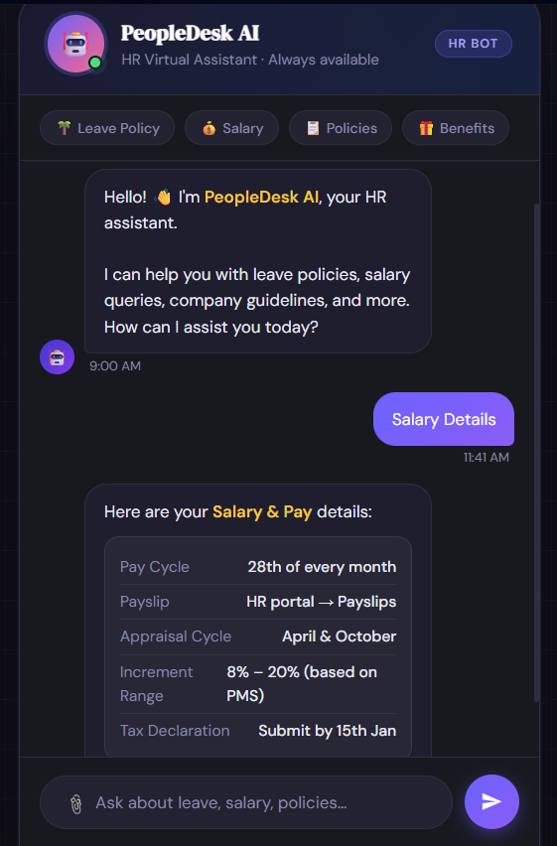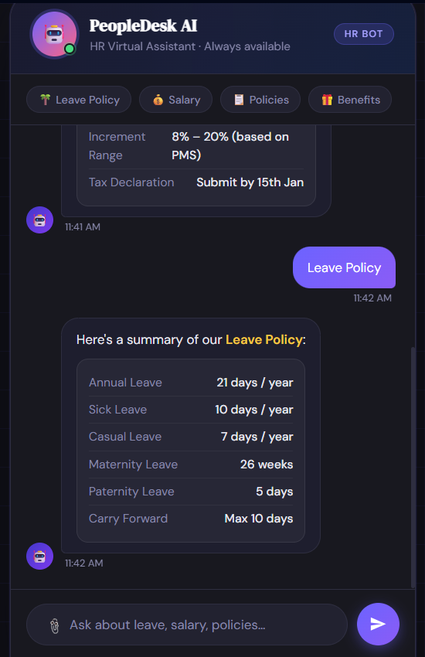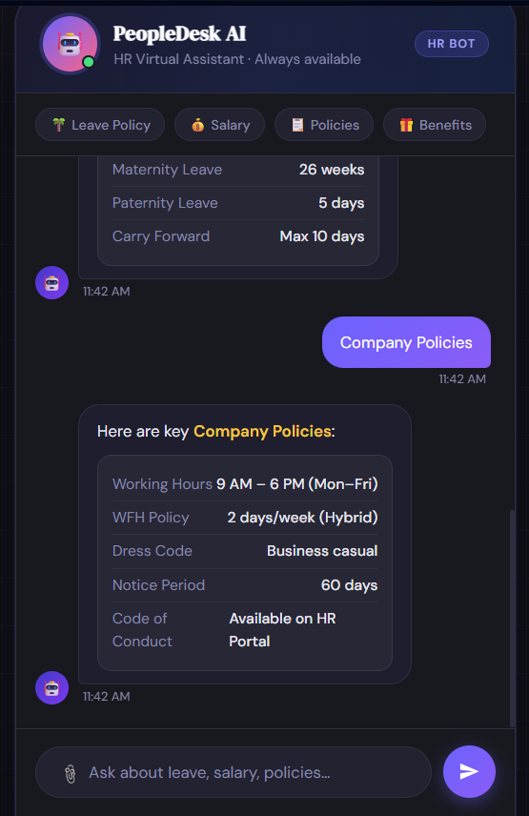

RESULT:
The HR Employee Support Chatbot was successfully developed using HTML, CSS, and JavaScript. It provides quick responses to employee queries related to leave, salary, company policies, and basic greetings. This chatbot helps reduce HR workload and improves employee support efficiency.

